Go to Manage Jenkins 🡪 Go to Manage Node

Select New Node

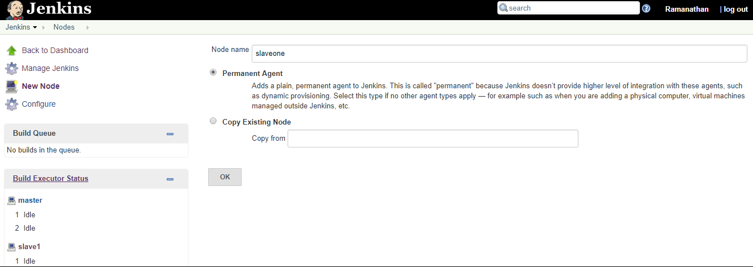

Node name : Provide respective node name

Select OK button

System lead to new node configuration screen

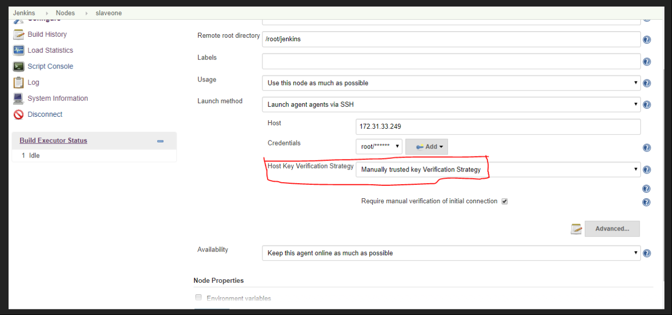

Host Key Verfification Strartegy : Manual Provider

Name : Provide name of the Slave

# of executors : 1

(Maximum No. of concurrent jobs)

Remote root directory : **Provide existing directory at *Slave***

Launch Method : select via SSH

Host : Private ip adress of Slave

Credntials : Provide Slave Root User and Root Password

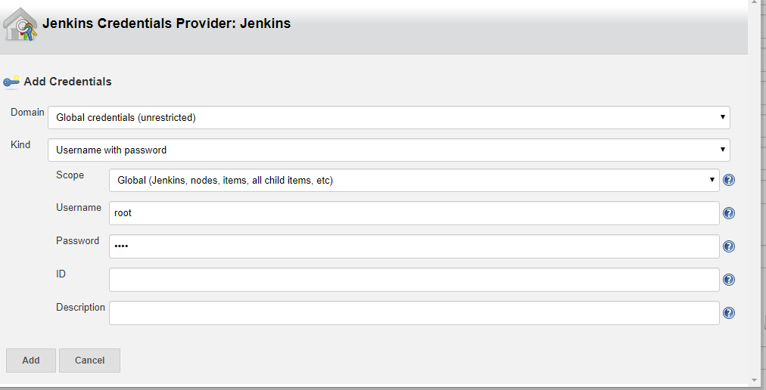

Save the node configuration

Wait 2 to 3 minutes, you get below screen shot which indicates that Master added Slave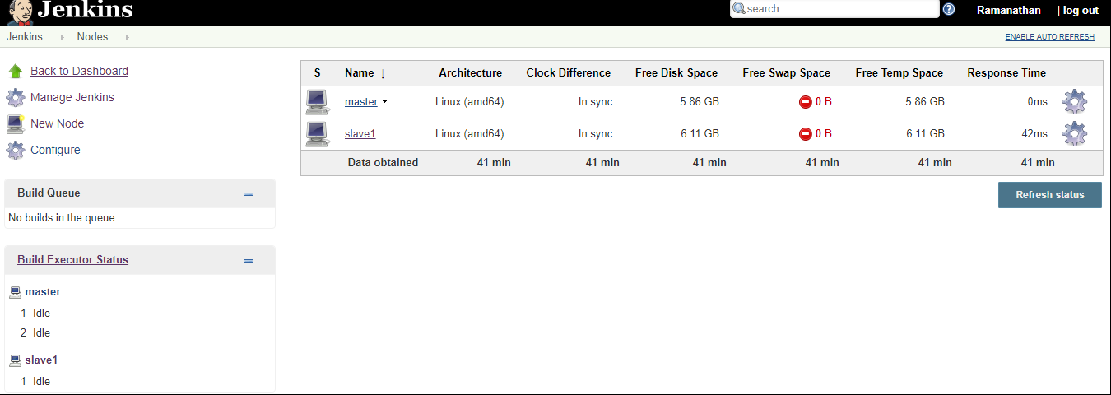

Create new job (freestyle)

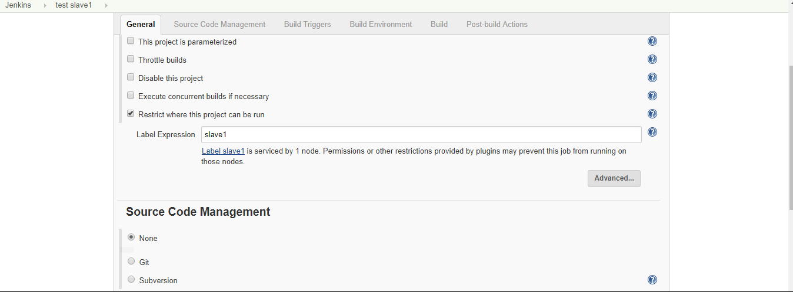

Label Expression : Select name of the Slave node

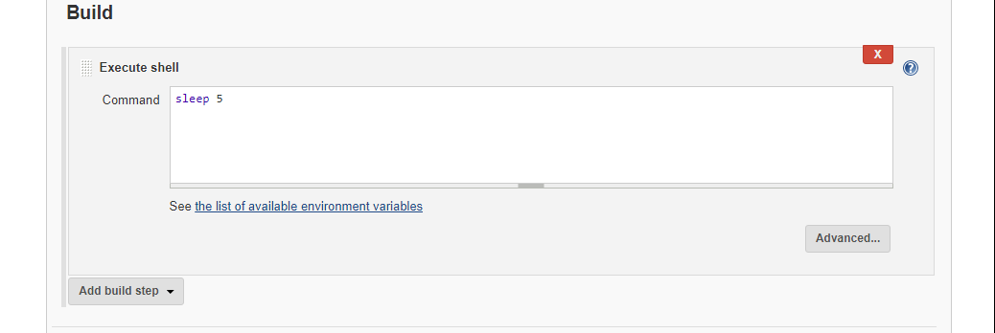

At Build Section, select execute shell

At Command area, provide simple Linux commands

sleep 5

Save the Job and Build the job

After completion of Job

You get this job generated under Slave not Master

Below screen shot is indicating that this job executed under slave1

